Information for Residential Aged Care
It is important to understand that an Advance Care Planning document completed by a Resident for themselves is the best information. If a Resident is admitted with a Victorian Advance Care Directive, do not ask them to transfer the information to a facility Advance Care Planning form unless they want to update their Advance Care Planning document.
Similarly, do not ask a family to transfer the information from an Advance Care Directive, completed by a person with capacity, onto a facility form if the Resident has now lost capacity. This is exactly why the Advance Care Directive was completed, and it is now time to use it.
The RACF Goals of Care form can be a way to bring together the Advance Care Planning with the information that is now available about the Resident’s health condition.
The RACF Goals of Care form is a summary of their medical treatment plan. It describes the treatment that the Resident or their MTDM consents to within the limits of what might be possible. It is clear information that can be accessed quickly in a crisis and acted upon. Think of the RACF Goals of Care as a ‘now care plan’. It is based on the current illness context. If that illness context changes, the Goals of Care will need to be updated. Similarly, if a Resident with capacity to change their mind about the treatment they would consent to, their Goals of Care will also need updating.
In Victoria, there is a range of support available depending on your location:
- Your local Residential InReach service
- Victorian Virtual Emergency Department based at Northern Health
Home – Victorian Virtual Emergency Department (vved.org.au)
- Palliative Care Advice Service
Phone: 1800 360 000 (7 am-10 pm every day)
- Community Palliative Care Services
If you have questions about interpreting Advance Care Planning documents, it may be helpful to speak to the Office of the Public Advocate Victoria if you don’t have someone to seek advice from.

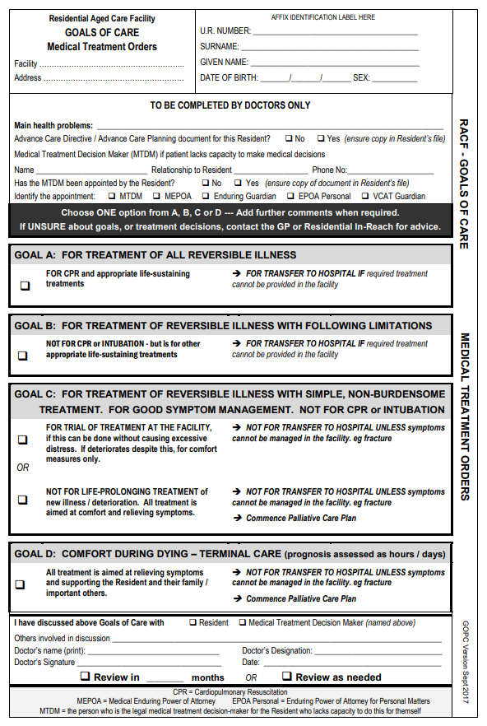
Aged Care Facility Goals of Care Form

