People who lack capacity (ability) to do Advance Care Planning
Only a person with capacity can appoint someone as their Medical Treatment Decision Maker or complete a Victorian Advance Care Directive.
Advance Care Directives are intended to be completed by a person for themselves. Even if a person lacks capacity to complete an Instructional Directive, they may be quite able to communicate what is important to them using a Values Directive.
In practice, there are documents called Advance Care Plans that are completed on behalf of a person lacking capacity to do so. The person completing them should be trying to write down what they already know about the person’s preferences and values. That is, they should seek to make a written record of past verbal Advance Care Planning.
At Northern Health, our preference would be to use the Victorian Form –
‘What I understand to be the person’s preferences and values’ form: information to help guide future medical decisions for a person who is unable to express their own preferences.’
This form is for people who cannot make medical decisions or express what they want.
It can be completed by the Medical Treatment Decision Maker and/or others the person knows well. Sometimes, this may be professional carer. Sadly, some people have no family or friends.
What is written in this form will help the Medical Treatment Decision Maker and health professionals to make the medical decisions that the person would want.
If there is no Medical Treatment Decision Maker, then someone from the Office of the Public Advocate may be required to consent to the person’s treatment, and the information in this form will be very helpful for them to understand what is important to the person.

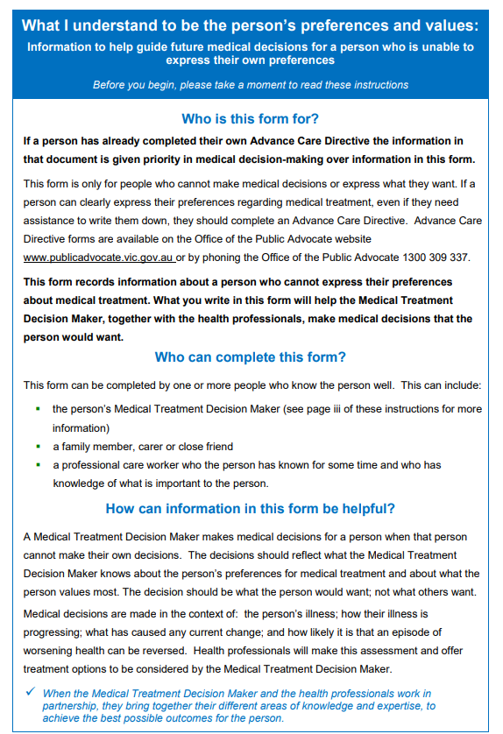
Preferences and Values form.

